EX NO: Three Address Code into target machine instructions.

Aim
To write a C program to generate target code from three-address code.

Algorithm
- Start the program.
- Declare variables to store the result, operands, operator, and TAC statement.
- Read each TAC statement from the user.
- Stop reading when the user enters END.
- Check whether the statement is an arithmetic operation.
- Generate target instructions using MOV, ADD, SUB, MUL, or DIV.
- For simple assignments, generate a MOV instruction. Stop the program.

Program:
#include <stdio.h>
#include <string.h>

int main()
{
char result[20], op1[20], op2[20], oper;
char tac[100];
int i = 0;

printf("Enter Three Address Code:\n");
printf("Enter END to finish.\n");

while (1)
{
fgets(tac, sizeof(tac), stdin);

if (strncmp(tac, "END", 3) == 0)
break;

if (sscanf(tac, "%19s = %19s %c %19s",
result, op1, &oper, op2) == 4)
{
printf("\nTarget Code:\n");
printf("MOV R%d, %s\n", i, op1);

switch (oper)
{
case '+': printf("ADD R%d, %s\n", i, op2); break;
case '-': printf("SUB R%d, %s\n", i, op2); break;
case '*': printf("MUL R%d, %s\n", i, op2); break;
case '/': printf("DIV R%d, %s\n", i, op2); break;
default:
printf("Invalid operator\n");
return 1;
}

printf("MOV %s, R%d\n", result, i);
}
else if (sscanf(tac, "%19s = %19s", result, op1) == 2)
{
printf("MOV %s, %s\n", result, op1);
}
else
{
printf("Invalid Three Address Code\n");
}

i++;
}

return 0;
}

Sample input:
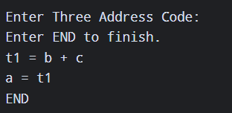

Sample output:
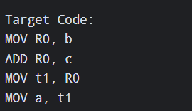

Result:

Thus, the C program successfully converts three-address code into target code.

